Mason Bee Nests

Solitary Bee Hotel / House ….

RED MASON BEE NESTS Spring houskeeping
Solitary bees are harmless and not aggressive. They do not live in hives, make honey, build honeycombs, or swarm. All the pollination benefits, no sting. ... In this case, mason bees, so named because they build their nests using dabs of mud to pack around each egg. These gentle, solitary bees are pollinating powerhouses. One mason bee can do the pollinating work of 100 honeybees.
If you have a Red Mason Bee nest overwintering in your garage or shed, March is the time to think about putting it back outside for the summer. The bees usually emerge in mid-April, when (we hope) temperatures will remain steady!
Before putting the tubes out, however, it is a good idea to do some spring-cleaning. Check all your individual small tubes. Any that are empty can be re-used, though it is best to riddle them out with a bit of stiff wire to remove any old mud or gunk inside. Any tubes obviously damaged, wet, mouldy etc. can go on the compost heap.
Any which you marked last spring with Tippex can be riddled out, as they did not hatch over last summer. The tubes which were filled by the bees last year will have a mud seal at the entrance. You can’t at this stage tell whether they will hatch out or not. If you put a small blob of Tippex on the mud seal NOW, you will be able to tell which ones hatch out and which don’t. Then in the autumn you can clear out the unhatched tubes for re-use next year. When everything is cleaned up, hang the container in a sunny position at between 3 - 4 feet from the ground, without overhanging foliage.
To stop rain getting in, align it slightly downwards, but be sure the tubes are not loose enough to fall out – jam them in with some corrugated cardboard.
Then look forward to lots of free pollinators getting to work on your fruit veg and flowers!
To make a bee hotel / house you will need, a piece of plastic household downpipe (1/2” longer than bee tubes), Gorilla wide All Weather Outdoor Waterproof Tape or similar to cover one end of downpipe, 30 Mason Bee Tubes are 150mm long and have an inner tube diameter of 7-8mm (Amazon or CJ Wildlife), corrugated cardboard, 2 plastic cable ties (from hardware shop or Amazon), strong thick green garden wire for hanging up downpipe. Small piece cardboard for inside covered end of downpipe.

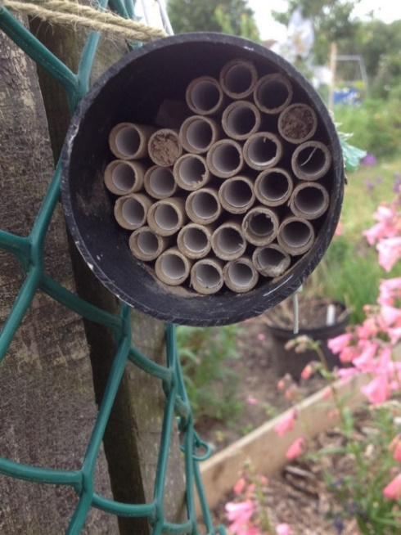
Empty Bee Nest

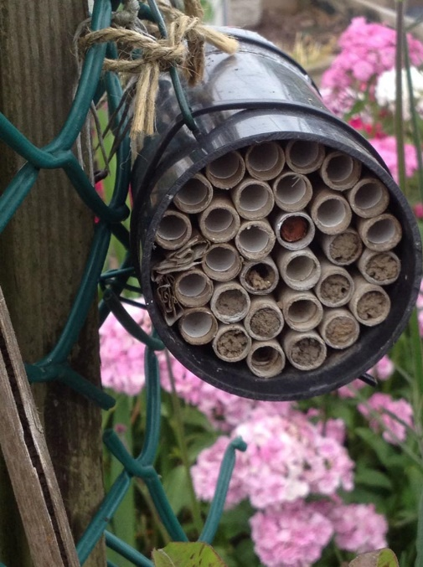
Half filled nest.
The front of the house (with tubes showing) should have a south or southwest exposure where it will get the most sun.

